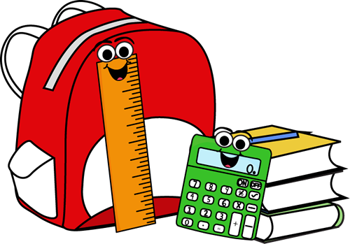

NMES Grade Two
School Supply List 2017 - 18

- A $45.00 supply fee to cover supplies that can be colour-coded and organized for each student.
- 2 boxes of Kleenex.
- If your last name is A-M – bring Large Ziplock Bags
- If your last name is N-Z - bring a package of 10 page protectors.
- 1 Package of Whiteboard Markers
- Indoor sneakers (please purchase sneakers that will allow your child to participate in gym safely – they should be able to be fully tied or fastened).
- 1 USB (Can use last year’s)

Other Suggested Items:
- A sturdy reusable water bottle.
- A change of clothes including socks, underwear, pants and a shirt in the case of a playground incident.

